Name: Luigio ‘Gary’ Colombo
Photo:
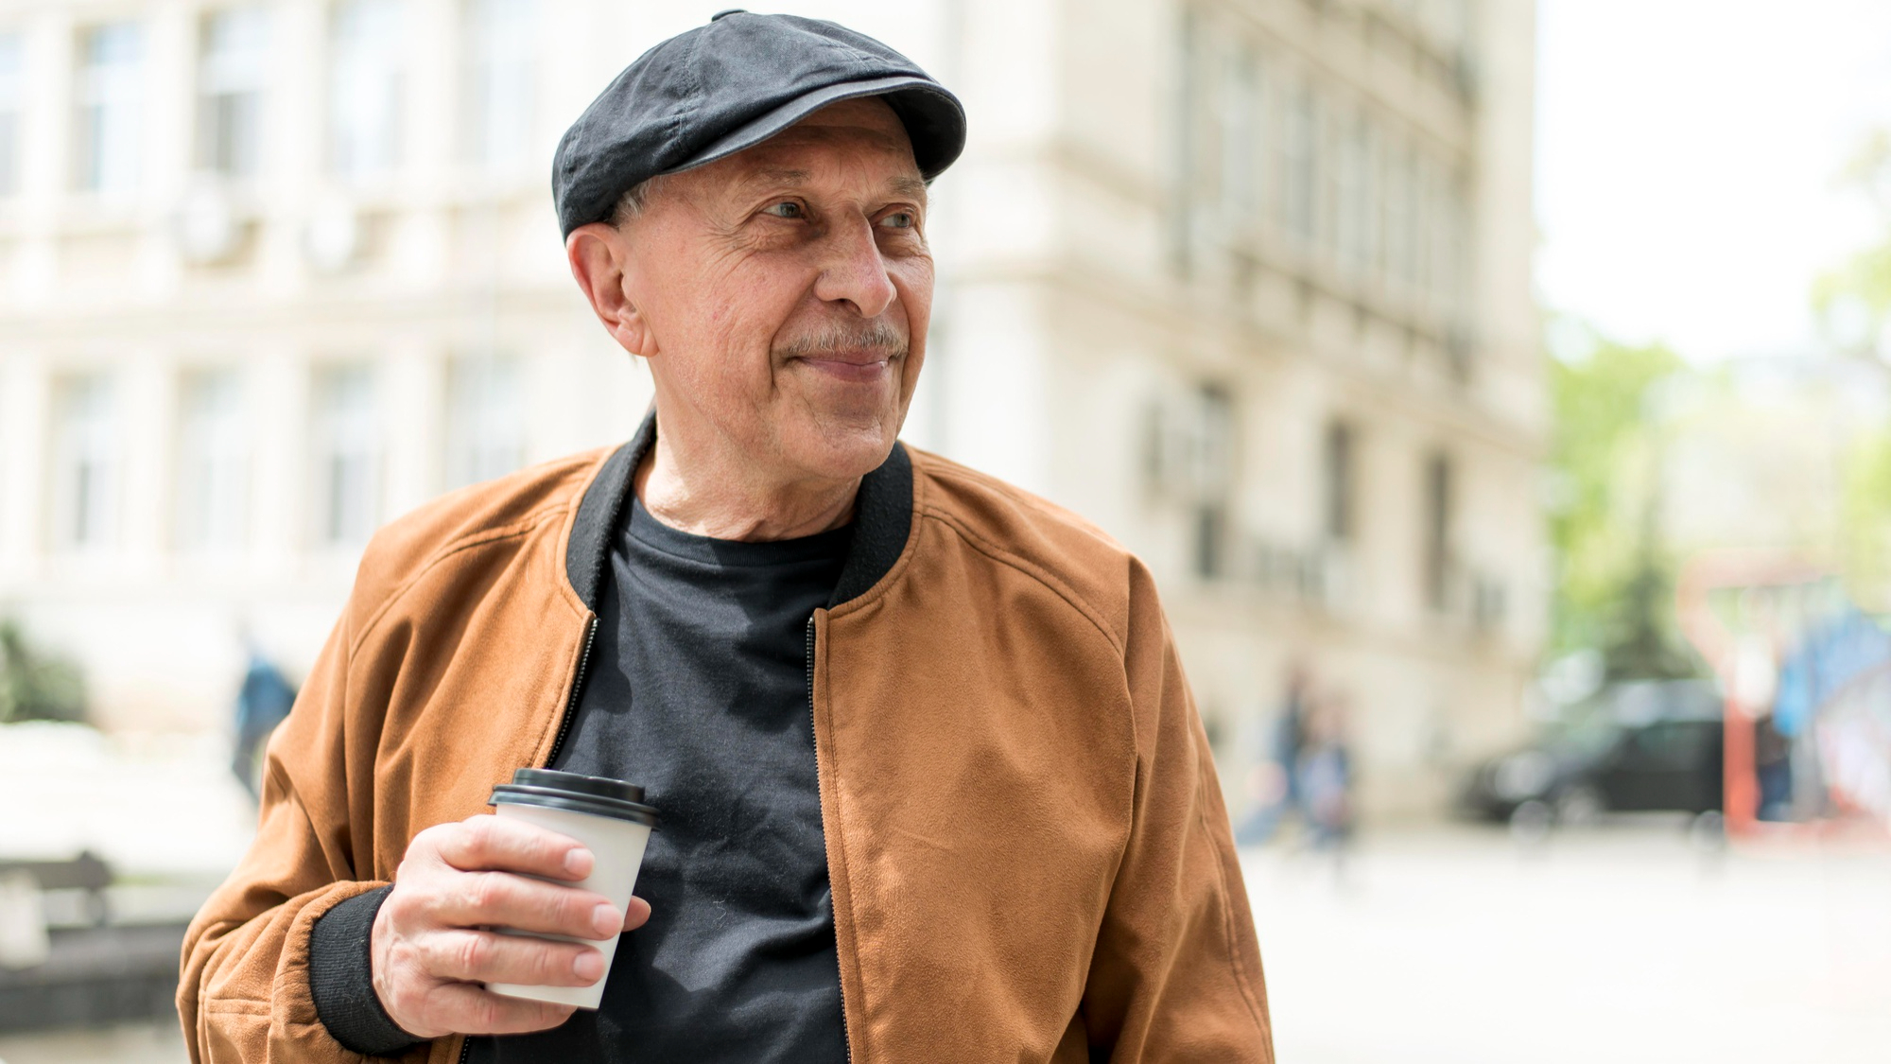
Tag Line: “A baker’s hands, a survivor’s heart”
Age: 63, born October 17th, 1962, San Severo, Italy
Language: Italian and English
Disability: Colourblind (Distinguish between Red and Green)
Family: 2 kids - (1 son. 1 daughter). 4 Grandchildren. Wife passed away.
Favourite Places: His Bakery, Park, Market, Butcher
Education Level: Passed High School, after moving to South Australia from Italy he opened a bakery and studied Certificate III in Patisserie at Tafe SA.
Business Interaction:
Hardware and Software use: Has an old 2011 Samsung Galaxy ACE – (3G ,5MP rear camera, 2GB microSD card), Laptop – 2023 MacBook Air M2 chip(13.6-inch Liquid Retina display (500 nits), 16GB RAM , 512 GB storage)
Four Grokkability Items:
- Loves cycling around town in his old, rusted bicycle
- Always tend to spend less than 10 dollars for a meal
- Daily visits his bakery to check up on how the business is running
- Always smiles at people but truly living with depression after his wife's death
Personality Cues:
- “Core workers say he is very hardworking”
- “Luigio is very unlucky in life”
- “Being asked about the colour of something during work by a customer”
Story: He was born in Italy and lived there for 18 years until he met his future wife and they ran away to South Australia in 1980. He went on to study Patisserie after 3 years living in South Australia on little income, leading him to open his Bakery “Colombo’s Pastries” in 1984. His wife passed away suddenly on the day of the Bakery’s 1 year anniversary, 24th September 1985 at 21 years old. Purpose of Luigio using the website is to adopt a Barbet dog as he is lonely and wants a companion after his wife's death. Moreover, he is going to be using the website after work in the nighttime in his bedroom. Luigio is a person who is goal oriented and never lets his disability get in the way.

Preferred Dog: Barbet
https://furlyfe.com/dog-breeds/barbet/

